Word Search Application Specifications

Written in Java with Spring Tool Suite 4

Thymeleaf for client template

Maven for build automation

H2 database – in memory database used to hold word list

MVC architecture

Stored on github at https://github.com/marshallrandom/wordsearch

Instructions

After launching the application launch a browser to URL <http://localhost:8080>

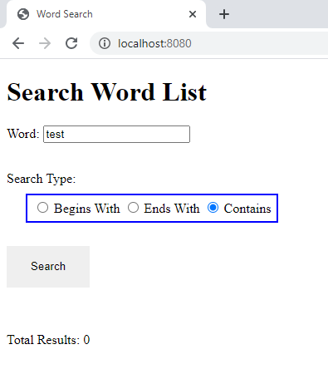

Text can be search by entering the text to search for in the text box, selecting from the 3 search options “Begins With”, “Ends With”, or “Contains”, then press the “Search” button.

“Contains” search performed

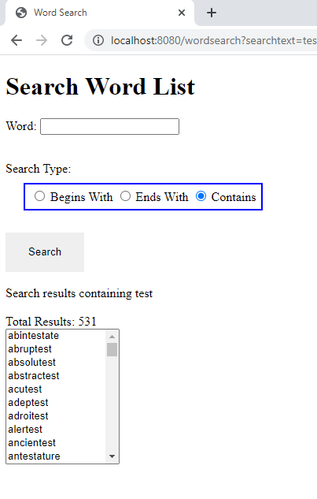

“Begins With” search performed

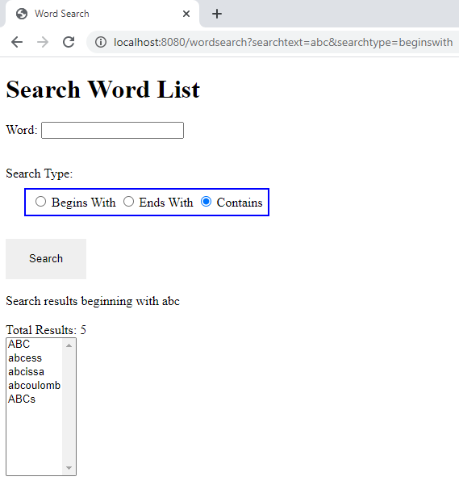

“Ends With” search performed

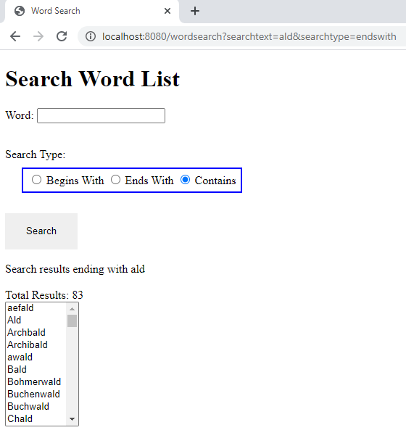

When “google” is typed as a search term and waiting a few moments or clicking out of the text box the google logo should appear on the bottom:

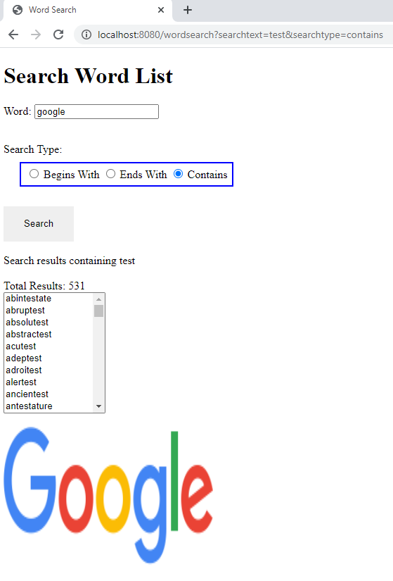

And the Foxconn building if “Foxconn” is entered

